CALL FOR PAPERS
Special Session on <Title goes here>
SPIES 2019-The International Conference on Smart Power & Internet Energy Systems
April 25-27, 2019, Melbourne, Australia
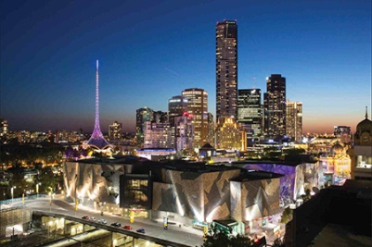

TOPIC OF THE SPECIAL SESSION

Abstract: Outline of the session goes here (100-150 words)

ORGANIZED AND CO-CHAIRED BY
Organizer I email address
Organizer I email address
…

Schedule:
Deadline for submission of special session paper to Special Session Organizer- December 31, 2018
Notification of acceptance – January 31, 2019
Deadline for submission of final manuscripts to the Special Session Organizer- February 15, 2019

